**How to enable *Microsoft Teams Meeting* button in outlook**

If the Microsoft Teams meeting button is not appearing in Outlook. This SOP will help to fix this problem. Users can organize to start and schedule meetings using outlook.

1. Open MS Teams> go to manage accounts

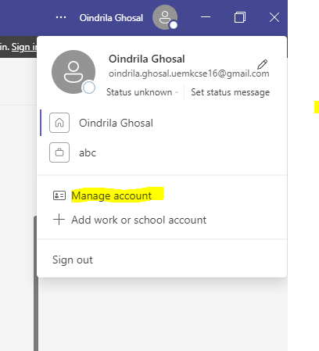

1. Click on General and select “Register Teams as the chat app for Office (requires restarting Office applications)”

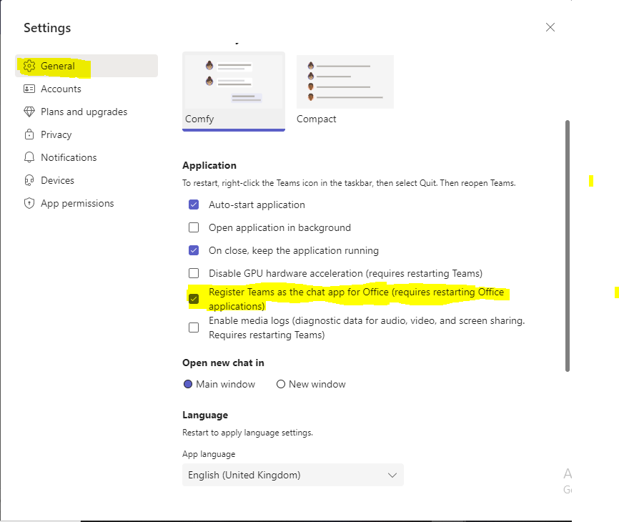

1. Now open outlook> Go to file> click on the option

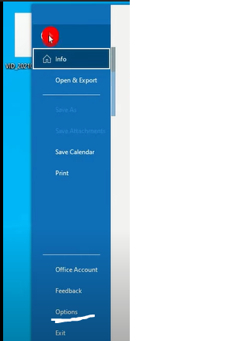

1. Click on Add-ins> click on go> then OK

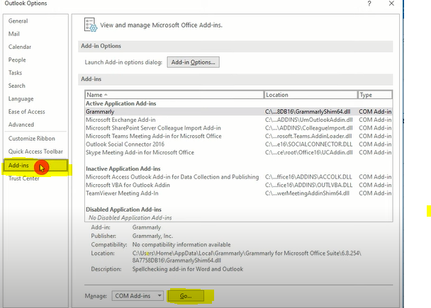

1. Then select “Microsoft Teams Meeting Add-in for Microsoft Office”> click on OK

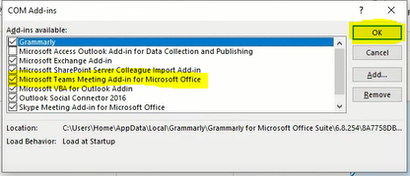

1. After that, Teams meeting button will appear in outlook. Users can easily schedule a meeting through this.

